**QUESA**

***Summer Internship Report(2019-20)***

**BACHELOR OF TECHNOLOGY**

**IN**

**COMPUTER SCIENCE AND ENGINEERING/**

**COMPUTER SCIENCE**

**Submitted by**

**VANYA SRIVASTAVA (1802910181)**

**2 (C)**

**Supervised by**

Prof………



**DEPARTMENT OF COMPUTER SCIENCE AND ENGINEERING**

**KIET GROUP OF INSTITUTIONS, GHAZIABAD, UTTAR PARDESH**

**(Affiliated to Dr.A.P.J. Abdul KalamTechnical University, Lucknow, UP,India)**

**Session2019-20**

**Certificate**

PART – A

1. Introduction
2. Project Overview
3. Implementation (with snap shots)
4. Conclusion
5. Daily Log

PART – B

1. Summary of Paper-1
2. Summary of Paper-2
3. Summary of Paper-3
4. Summary of Paper-4
5. Summary of Paper-5

PART –C

1. Certificate of MOOC-1
2. Certificate of MOOC-2

**CERTIFICATE**

This is to certify that the internship project report entitled, **“QUESA”** submitted by VANYA SRIVASTAVA in the Department of Computer Science & Engineering of KIET Group of Institutions, Ghaziabad, affiliated to Dr. A. P. J. Abdul Kalam Technical University, Lucknow, Uttar Pradesh, India, is a record of candidatesummer internship work carried out by him / them under my supervision and guidance and is worthy of consideration for the same.

**Signature of Supervisor:**

**Supervisor Name:** Prof.….

**Date:**

**PART - A**

1. Introduction

This document is prepared in order to determine a software requirement specification for Quesa. Quesa is a question-and-answer site where question are asked, answered, edited, and organized by its community of users in the form of opinions. Any person who is registered with the website can ask any question and all others will get a chance to answer it and the questioner will get different opinions or answers from different people. Another person who has same question can also view all the answers and get the knowledge. Users can also collaborate by editing questions and suggesting edits to answers that have been submitted by other users. A vast amount of knowledge that would be valuable to many people is currently available to few people’s heads,or only accessible to select groups. So, it connects the people who have knowledge to the people who need it, to bring together people with different perspectives so that they can understand each other better, and to empower everyone to share their knowledge for the benefit of the rest of the world.

Question and answer websites are way useful for the people who are not only looking for the quantity but also the quality of the answers to their questions. In today’s era, the majority of people rely on the opinion of others or rather experts in a particular field. QUESA provides an interface for these people and is fulfilling all their needs.

One of the main purposes of this website is to provide a platform for the people who need various quality opinions on any topic. Question and answer websites can be described as a system that is mainly designed to allow users to ask questions as well as respond to questions on a vast array of topics .

1. Project Overview

Quesa is a website for question-and-answers. Every person can use it online without a fee. People from different regions of the world can connect to it and exchange information with other people. Question and answer websites are way useful for the people who are not only looking for the quantity but also the quality of the answers to their questions.

Quesa does not require any specific computer knowledge to use it except the developers and administrators of it. Standard users are thought to be from any age, any gender and from any nationality who can use just computer’s browser. On the other hand, administrators and potential developers need a high level of expertise to understand web technologies.

Users can collaborate by editing questions and suggesting edits to other user’s answers. The aim of Quesa is to provide information to the users about each and every field of society.

* You can ask questions
* You can answer questions (anonymously if you desire)
* You can comment on answered questions
* You can vote-up or vote-down answers to questions
* Questions can be assigned to topics
* You can write a post (a informative statement, rather like a orphaned answer or blog post)
* You can follow questions, topics or other users

1. Implementation (with snap shots)

The client-side of this website will be developed using the HTML, CSS, Javascript. HTML and CSS will mainly be used to create the static content of the web pages. Javascript will fulfill the dynamic requirement of the webpages. There will be a login page for the users to login.

The database will be created from SQL as it is a domain-specific language used in programming and designed for managing data held in a relational database management system, or for stream processing in a relational data stream management system. This will be required to store all the information entered into the website. All the data regarding the users and also the questions and answers.

The webpages and the database will be linked i.e. the server-side will be developed using Django which is a Python-based free and open-source web framework that follows the model-template-view architectural pattern.

Title Page:

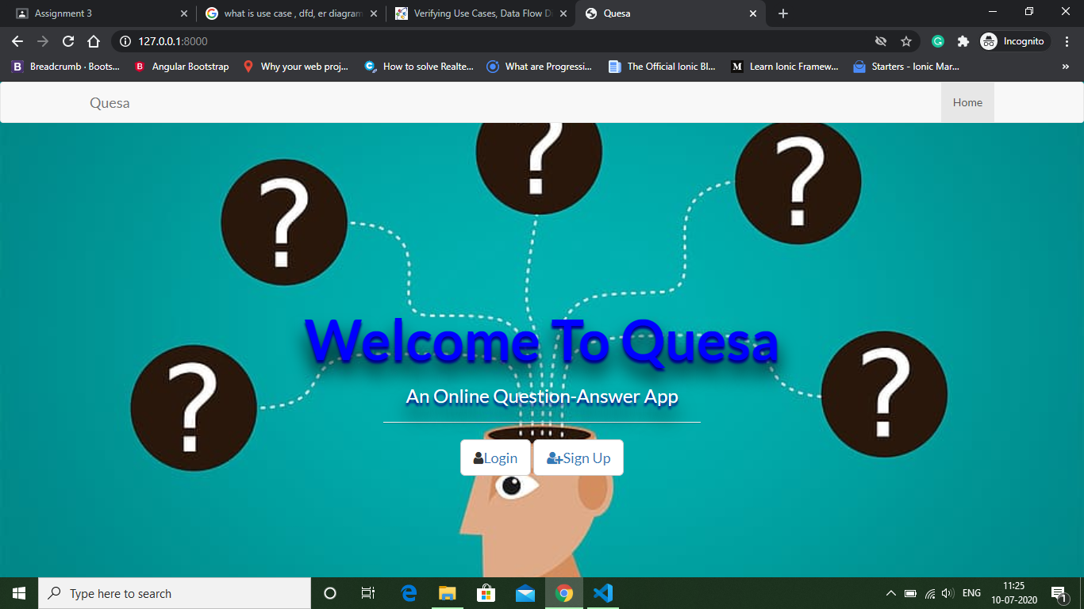

Login Page:

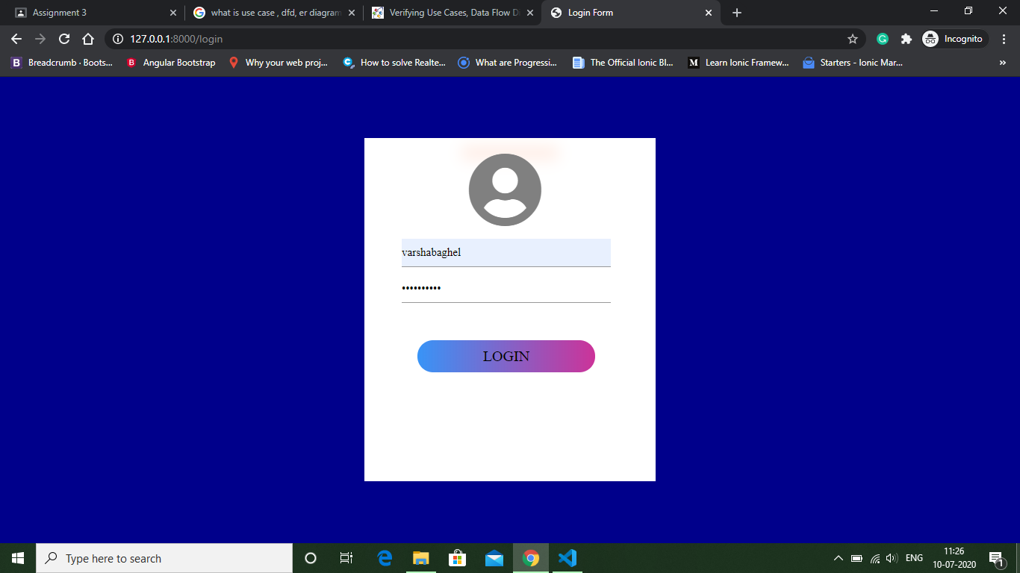

Signup Page:

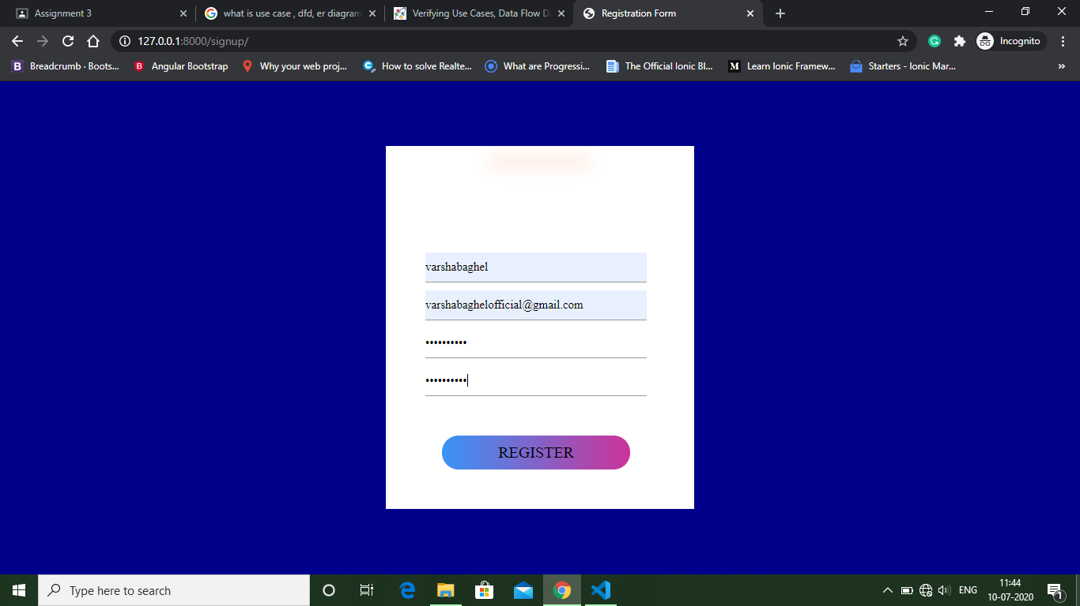

Home Page:

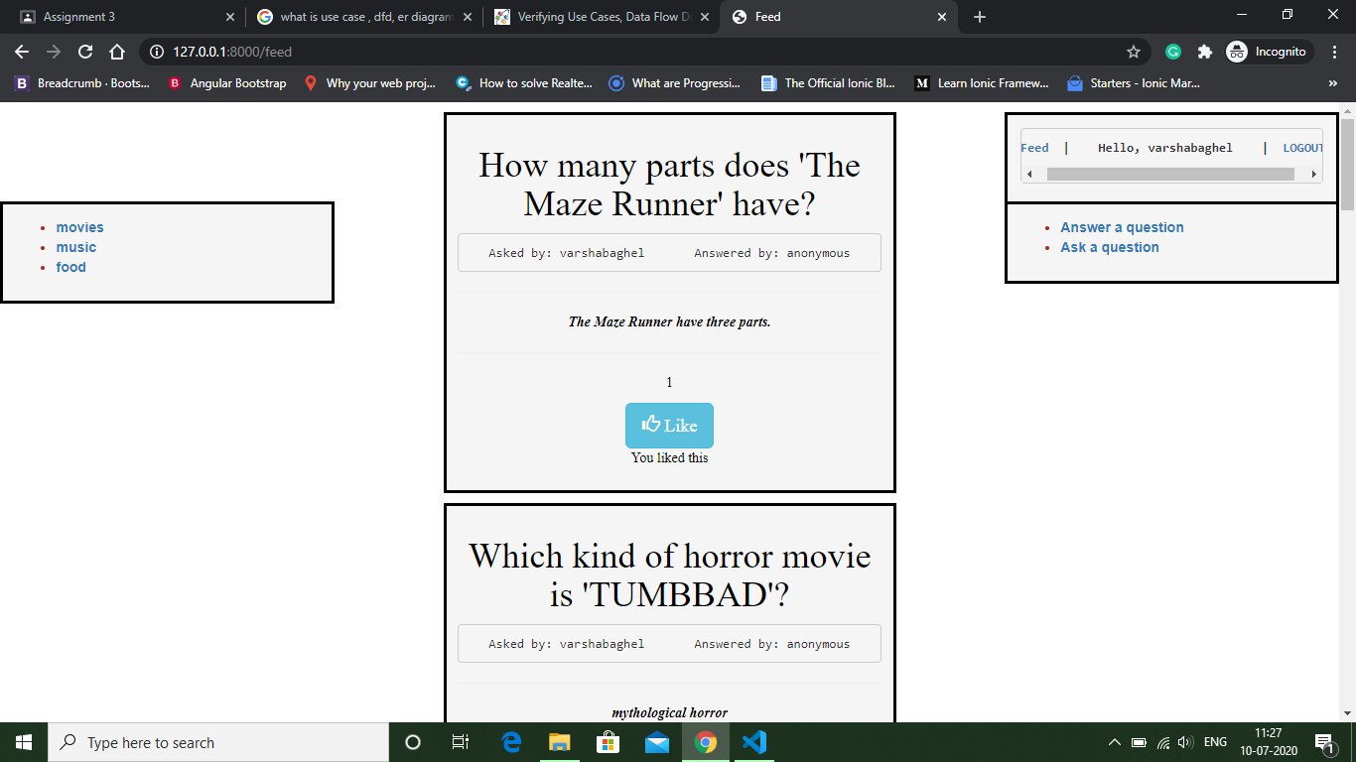

Ask a Question Page:

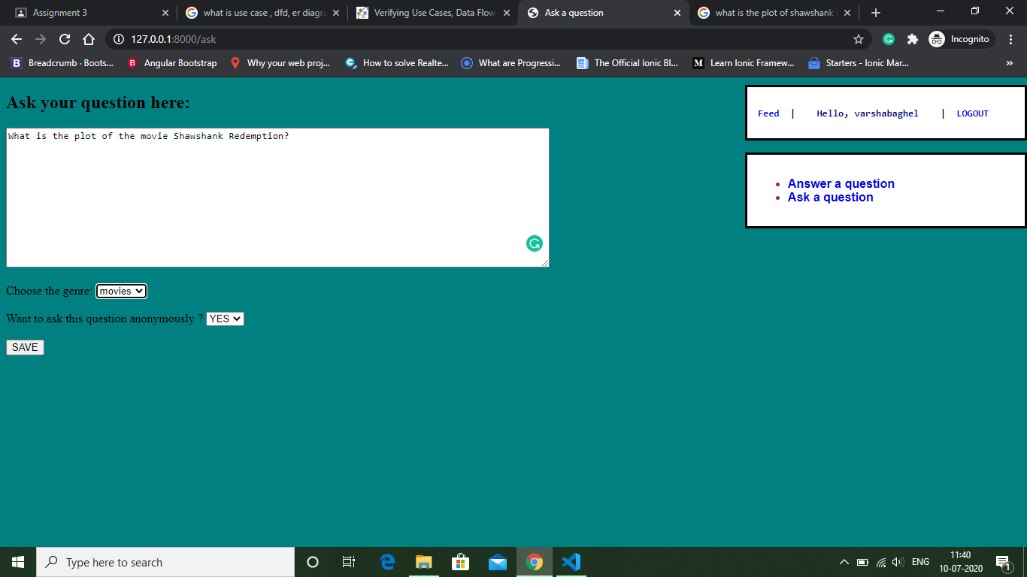

Answer a Question Page:

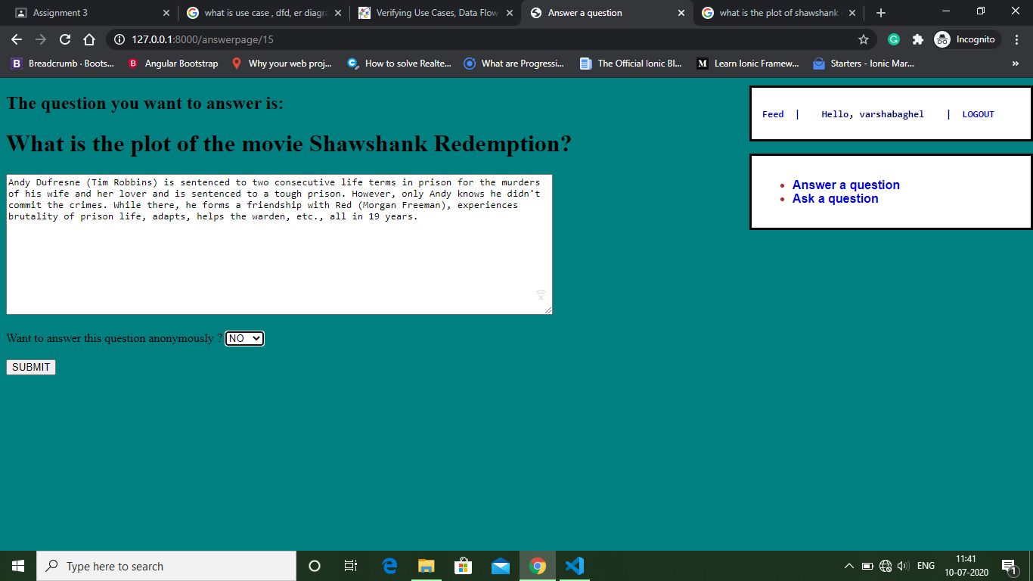

1. Conclusion

Question and Answer site is a factor among the many which boosted up and popularized the vision of the social Web. It enables community members to post high valued answers to globally asked questions and information seekers to grab intellectual information in a contextual, concise, and meaningful format at the cost of investing a few minutes. This study presents a common architecture and a comprehensive review of such sites.

A critical and analytical investigation of question and answer sites and relevant literature has been carried out with the intention to explore the noticeable features of such sites. The review contributes an extensive knowledge about question and answer systems and aimed to be helpful for new learners to grab a broad picture of such systems in a single platform. The domain is in its infancy and requires tremendously efforts from the community to explore its salient aspects to the human world. The study inspects question and answer sites on a large scale and makes an original contribution by presenting a comprehensive review, future challenges, and a generic architecture of question and answer sites.This site can not only  be used to find peoples thoughts and opinions about a particular topic but will also will help in finding experts in various fields.

1. Daily Log

|  |  |
| --- | --- |
| **Name of Student** | VANYA SRIVASTAVA |
| **Roll No.** | 1802910181 |
| **Name of Course** |  |
| **Date of Commencement of Training:** | 16 May 2020 |
| **Date of Completion of Training:** | 30 JUNE 2020 |

|  |  |  |
| --- | --- | --- |
| **S.No.** | **Please specify the learning of the day** | **Date** |
| 1 | HTML ans CSS basics | 16/5/20 |
| 2 | Making a time table using html and css | 17/5/20 |
| 3 | Creating SRS of the project | 18/5/20 |
| 4 | Making title page | 19/5/20 |
| 5 | Creating Login and Signup page using html, css and bootstrap | 20/5/20 |
| 6 | Creating synopsis of the project | 21/5/20 |
| 7 | Sql basics and more about database management | 22/5/20 |
| 8 | Linking of all the pages to the database | 23/5/20 |
| 9 | Working on home page | 24/5/20 |
| 10 | Making ask a question and answer a question page | 25/5/20 |
| 11 | More styling on the pages | 26/5/20 |
| 12 |  |  |
| 13 |  |  |
| 14 |  |  |
| 15 |  |  |
| 16 |  |  |
| 17 |  |  |
| 18 |  |  |
| 19 |  |  |
| 20 |  |  |
| 21 |  |  |
| 22 |  |  |
| 23 |  |  |
| 24 |  |  |
| 25 |  |  |
| 26 |  |  |
| 27 |  |  |
| 28 |  |  |
| 29 |  |  |
| 30 |  |  |

**Supervisor's Sign**

**(Name)**

**PART - B**

1. **Title of Research paper-1**

**Summary:**

1. **Title of Research paper-2**

**Summary:**

1. **Title of Research paper-3**

**Summary:**

1. **Title of Research paper-4**

**Summary:**

1. **Title of Research paper-5**

**Summary:**

**PART - C**

**Certificate of MOOC – 1**

**Certificate of MOOC - 2**